**“ONLINE STOCKS INVENTORY MANAGEMENT SYSTEM FOR TOP GLASS ALUMINUM CENTER”**

**Erojo, Juvercinet**

**Lerio, John Mheg**

**Llorente, Dexter Louie**

**Loay, Cherwin**

**Lonquino, Trescia**

**Perseveranda, Joshua**

**Royol, Francis**

**Santiago, Kyle Clarence**

# TABLE OF CONTENTS

TABLE OF CONTENTS 2

ACKNOWLEDGEMENT 4

CHAPTER 1 INTRODUCTION 6

1.2 Mission and Vision 7

1.2.3. Statement of the Problem 7

Objective of the Study 8

1.2.3 Significance of the Study 8

1.3 Scope 9

CHAPTER 2 METHODOLOGY OF THE STUDY 11

2.1 Methodology of the Study 11

2.2 System Development Life Cycle (SDLC) 11

2.3 SDLC Diagram (Agile Methodology Chart) 14

CHAPTER 3 DATA GATHERING 15

3.1 What is Data Gathering? 15

3.2 Interview 15

3.3 Internet 17

3.4 Brainstorming 18

3.5 Adviser 19

3.6 Sample Thesis 20

3.7 Relevance of Sample Thesis 21

3.8 Sample Report 21

CHAPTER 4 DOCUMENTATION OF THE CURRENT SYSTEM 23

4.1 Definition 23

4.2 Description of the Current semi-manual System 23

4.3 Hardware and Equipment Set-up 24

4.4 Software being used 25

4.5 Personnels (5) 25

4.6 Context diagram of the current system 27

4.7 Level 0 Diagram 27

CHAPTER 5 SYSTEM DESIGN AND SPECIFICATION 28

5.1 System Design 28

5.2 Website UI`s 29

CHAPTER 6 SYSTEM IMPLEMENTATION 34

6.1 Definition 34

6.2 Hardware and Software Installation 34

6.3 Configuration and customization 39

6.4 Data Migration 40

6.5 Backup & Data Recovery 40

6.6 Testing (Testing the system on the client part) 41

6.7 Training and Implementation used. 41

CHAPTER 7 JUSTIFICATION AND CONCLUSION 42

7.1 Justification 42

7.2 Conclusion 42

CHAPTER 8 RECOMMENDATION 43

8.1 Recommendations: 43

**Approval Sheet**

This is to certify that Capstone Project 1 entitled “Inventory Management System for Top Glass Aluminum Center” and the Research defense conducted by the following group members have been reviewed and approved by the following members of the panel:

Group Members:

|  |  |
| --- | --- |
| 1. Erojo, Juvercinet  2. Lerio, Johnmheg  3. Llorente, Dexter L.  4. Loay, Cherwin  5. Lonquino, Trescia  6. Perseveranda, Joshua | 7. Royal, Francis  8. Santiago, Kyle Clarence |

Panel Members:

Name: Mr. Michael S. Forbile

Signature:

The Capstone Project and the Research 1 defense conducted by the group members mentioned above have been evaluated based on their relevance, originality, research methodology, findings, and overall quality. The panel members have expressed their satisfaction with the work presented and its successful completion.

This document is the official approval sheet for the Capstone Project and Research 1 defense. The group members are now authorized to proceed with the necessary documentation and preparations for the final submission.

Date of Defense: July 1, 2024

Date of Approval: February 18, 2024

# ACKNOWLEDGEMENT

First and foremost, we extend our praises and thanks to God, the Almighty, for His Blessings throughout our research journey and its successful completion.

The researchers wish to express our deep and sincere gratitude to our esteemed research adviser, Mr. Jaypee Abando, and our respected panelists (Names of Panelists), for providing invaluable supervision and support during our research study. We are truly grateful for their empathy, patience, and the wealth of knowledge they imparted to us. Working and studying under their guidance was a privilege and an honor.

Our sincere thanks and appreciation also extend to our client, whose willingness to cooperate fully greatly contributed to the smooth completion of our research study. We are grateful for the time and knowledge they shared, which facilitated the successful execution of this study.

Furthermore, the researchers would like to extend our profound appreciation to all individuals who played a role in the completion of this study. We express our sincerest gratitude to those who have been with us from the beginning of our journey, as well as to those who offered their assistance to make this research endeavor possible.

# CHAPTER 1 INTRODUCTION

1. **BACKGROUND OF THE STUDY**

**1.1.1 HISTORY**

In 1997, (Mr. Carlos Mendoza Jr.) the CEO of the Company founded Top Glass and Aluminum Glass Center, a company specializing in architectural construction. His wife (Mrs. Roselyn Mendoza) managed the finances, while their eldest son (Mr. John Dave Mendoza) oversaw operations, and their youngest son (Mr. Jayvee Mendoza) served as the company secretary.

Top Glass specializes in the fabrication of high-quality doors, windows, and other architectural components. Renowned for their craftsmanship, they serve a diverse clientele including upscale neighborhoods, educational institutions, condominiums, and religious establishments.

Over the 27 years of business, Top Glass experienced significant growth, expanding to three branches, and establishing a warehouse facility. Despite their expansion, they still stick to their family-run roots, prioritizing quality, and customer satisfaction. They are highly respected in the construction industry.

TOP GLASS ALUMINUM AND GLASS CENTER, located at 44 JP Rizal Extension. Comembo, Makati City, has been a foundational element in constructing infrastructures since its establishment in 1997, renowned for its provision of superior aluminum and glass solutions. The 44 JP Rizal Extension. Comembo, Makati City serves as its primary business hub, and it branches across various regions, aiming to cater to a wider clientele and enhance accessibility to its products and services, alongside J3 Mendoza Hardware and Construction Supplies, established by (Jayvee Mendoza) in Arayat, Pampanga on August 19, 2021, specializing in supplying essential hardware and construction materials for residential and commercial projects, while J3 Mendoza Construction Supply, owned by (John Dave Mendoza) and located in Ibayo-Tipas, Taguig City, has been providing essential hardware construction supplies since January 03, 2022, and RD Mendoza Construction Supply owned by (Roselyn Mendoza) and situated in Kalawaan, Pasig City, has been operational since September 05,2022, contributing significantly to both residential and commercials projects.

## Mission and Vision

* 1. **Mission**
* To meet or exceed our customer’s expectation.
* To maintain high standards of honesty, integrity, and ethics.
* To emphasize long-term customer relationships, never short-term goals.
* To earn trust and respect through complete and reliable services.
  1. **Vision**
* To make our workplace, products, and processes as environmentally safe as possible.
* To improve our processes through study and teamwork, and constantly improve our quality and craftsmanship.
* To take pride in our workmanship and product quality.

## 

## Statement of the Problem

## 1.3.1 General Statement of the Problem

The using Microsoft Excel for inventory management has led to confusion and errors due to many records, and the manual process of listing items consumes significant time; hence, there is a need to develop and implement a new inventory system that tasks reduce time manual efforts, saves time and enhances accuracy to improve overall efficiency and productivity.

## 1.3.2 Specific of the Problem

* Excel`s inadequate inventory management oversight across all three branches.
* Excel manually typing the items that causes time-consuming.
* TGAC`s excel confidential files is not set a password it will be vulnerable to open or breach.
* Excel can be difficult to manage large inventory datasets/tables due to its limitations such as slow performance and a lack of features.
* Printed sheets are prone to be misplaced.

## Objective of the Study

* To design and develop an Online Inventory Management System for Top Glass Aluminum Center.
* To monitor how many products or materials have been added or reduced.
* To mitigate the risk of theft or loss of products.
* To keep an eye on the products of each branch they have without physically visiting the store. (Keeping notified. History, In and Out of Items).
* Developing a login module to authenticate the users first before they can access the inventory system.

## 1.4 Significance of the Study

**1.4.1 Company**

This will help the business keep track of documents, safeguard them, and make sure that only authorized individuals can access and use the program.

**1.4.2 School**

This study will add to the Datamex College of St. Adeline library's collection.of references, which can help students who are interested in learning and discovering similar topics.

**1.4.3 Proponents**

The purpose of this study is to help us, the supporters, enhance us understanding and skill in programming. It can help us grow as people and achieve success in the field of information technology.

**1.4.4 Client/Owner**

Provide clients to this company with peace of mind that their information and requests are properly managed and secured.

**1.4.5 Employees/Staff of the company**

Employees at the company will gain from this since it will make their tasks much easier and have less time.

**1.4.6 Future Proponents**

This shall provide additional information to future researchers who wish to do the same inventory system.

## Scope

* The system inventory will feature a login interface that allows authorized company staff to securely access and use the system, thereby safeguarding the integrity and confidentiality of the data.
* The existing records can be transferred into the new system including the previous 6 months’ inventory to the current inventory.
* All the items are categorized properly and convenient to find the products.
* The system keeps track of who changes the information and when ensuring accountability and transparency within the company.
* The system can generate a printed copy of the history and inventory reports.
* The system will be network-enabled, allowing authorized employees in different locations to access the same real-time inventory data.
* Super admin have a limited access and the Admin having specified access of the inventory system.

1. **Super Admin** – Can access the inventory system of all three branches but cannot perform releasing and receiving actions for branches outside his own branch.

1. **Admin** – Can only access the inventory system of his own branch.

**1.5** **Delimitation**

* The system inventory is not capable of processing sales.
* The system inventory is not capable of computing sales.
* The system inventory is not capable of generating sales reports.

# CHAPTER 2 METHODOLOGY OF THE STUDY

## Methodology of the Study

The methodology is the general research strategy that states how the study is initiated and what methods are used for the certain study. The methods that are used to implement the study define the kind of data gathering used such as interviews that indicate the history, missions, and visions, process operations, and sample reports that are taken by an audio/video recorder and taken of some of the photos. The following tools and equipment stated having a client's premise methodology is the general research strategy that states how the study is initiated and what methods are used for the certain study. The methods that are used to implement the study define the kind of data gathering used such as interviews that indicate the history, missions, and visions, process operations, and sample reports that are taken by an audio/video recorder and taken of some of the photos. The following tools and equipment stated have a client's permission.

Agile method project management is a flexible and iterative approach to project management. It emphasizes quick and adaptability methods that allow teams to respond effectively to changing requirements and customer feedback. The Agile method is simple to understand and follow, providing a structured yet adaptable way to arrange tasks and deliver value continuously.

## System Development Life Cycle (SDLC)

The system development life cycle (SDLC), also referred to as the application development life cycle, is a term used in systems engineering, information systems, and software engineering to describe a process for planning, designing, develop, testing, and review an information system.

The systems development life cycle concept applies the Agile method in a cycle structure and procedures getting the phase step-by-step method.

There are usually six stages in this cycle: planning, design, developing, testing, deploying, and reviewing.

* 1. **Plan**

In this thesis, the plan is to reduce the work time of listing the items manually and avoiding the repeating inventory in items.

An inventory system will be used to track every item, and this is the aim of requirements analysis. Inventory can also help to prevent product loss or theft.

* Giving reports regularly to client to keep informed about the project.
* Keeping client be in contact what are the changes in the project.
* Giving everyone a contribution about the project and teamwork to the group.
* Always practice the system regularly if there is an bug and what is the improvements of the system.
* Ensuring that the project management process is well-documented is crucial for future reference and sharing best practices within the organization.

**2.3.2 Design**

Complete descriptions of the design's features and functionalities are provided, together with screen layouts and user interfaces, inventory rules, process diagrams, and other supporting materials.

* 1. **Develop**

During this phase of system development, client suggestions will be incorporated into the software for the inventory system, along with any necessary tweaks or changes based on the needs of the clients.

* 1. **Test**

It is the carrying out, execution, or practice of a plan, a method, or any design to do something. Implementation is the action that must follow any preliminary thinking for something to happen.

* 1. **Deploy**

In this deployment stage where the system is about to deploy the system where the plans and system activities are running and ready to use the system to the client.

In the client, the system will be checked by the client if the inventory system is runnable and functionable. It will impact how the inventory system fast and reliable.

**2.3.5 Review**

We must test our system to make sure there are no bugs before we deploy it. This must be found to prevent errors, guarantee that all flaws have been corrected, and optimize our system before it is used.  
  
We need to execute several trials runs to make sure we meet our client's expectations. We must make sure the system is optimized and operational at this point in the test run before the owner uses it.

## A diagram of a process Description automatically generatedSDLC Diagram (Agile Methodology Chart)

# CHAPTER 3 DATA GATHERING

## What is Data Gathering?

## One of the studies proponents conducted an interview with our chosen client, Mr. Jayvee Mendoza who also Top Glass Aluminum Center Authorized Representative. We've gathered all the information we need to figure out on how to address our client’s problem of keeping the items, remaining stocks of the item, and keeping the record of their customers.

## Interview

The personal interview is the method that is used by the proponents to the client to gather the information. The proponents had their prepared questions for the client that could be answered. Before conducting an interview, the proponents ask for approval to the client to agree for the personal interview by showing a request letter. All of the answers and other information that is stated by the client is recorded, this is used as guide and reference by making the study. The recorded information and answers had permission from the client before starting the interview.

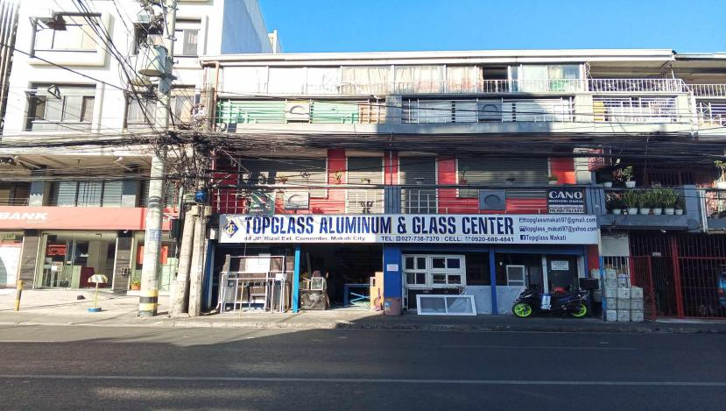

*Figure 1. Actual photo of the outer view of the exact building of the TOPGLASS ALUMINUM & GLASS CENTER.*

In this figure, it shows the actual building of the TOPGLASS ALUMINUM &. GLASS CENTER.

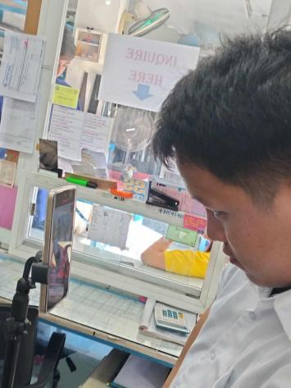

*Figure 2. Actual interview in TOPGLASS ALUMINUM & GLASS CENTER.*

This is the actual interview of the proponents to the client. We discussed it here, what are the plans for the system he wants to be developed and we suggest some of our ideas to make the system more reliable.

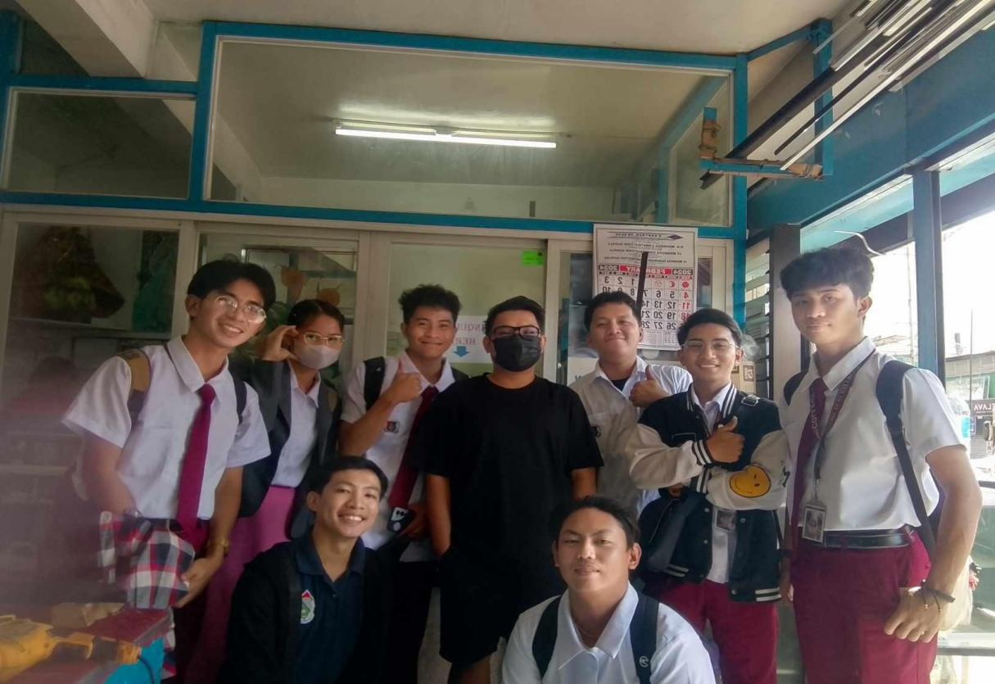

*Figure 3. Actual photo of the proponents and the client after the personal interview.*

The figure shows the proponents and the client after their interview with the client.

## Internet

Our group are researching some websites in order to help our system to develop.

Websites Visited are the following:

* <https://github.com/> - is used to research codes to develop a system.
* <https://chatgpt.com/> - is used to ask some questions for codes and debugs.
* <https://www.messenger.com/login/> - is used for communicating each other to make plan for the website or to reach out the proponents for the revision for the system.
* <https://www.figma.com/files/recents-and-sharing/recently-viewed?fuid=1343057087445174690> – Used for to make a plan how to design for the website.

## Brainstorming

Through brainstorming, teams can have more creative and innovative ideas during group discussions. When there are unclear or difficult-to-understand aspects of the project, the group members assist one another in putting the proposed solution into practice. It is the group's answer to project planning and information sharing for the few members of the group with lots of ideas.

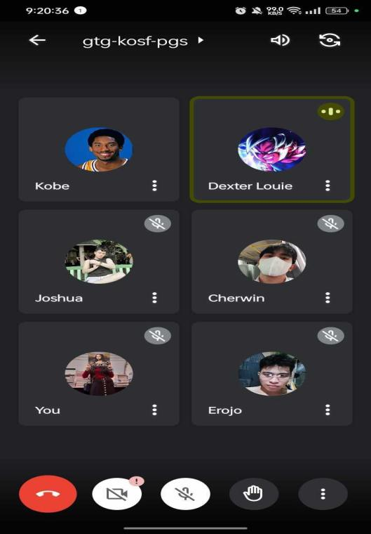The goal of brainstorming is to generate more ideas in a group setting. This is a useful method for coming up with ideas for themes, strategies, and other things. This is the decision-making process for creating backup plans for ideas.

*Figure .4. Brainstorming in Googlemeet on Feb. 26, 2024*

**Figure 3.4** In the photo, the researchers are brainstorming for the first time, discussing the identity of the individual client that will be the subject of the study. Including potential client acquisition strategies and fallback methods for client acquisition.

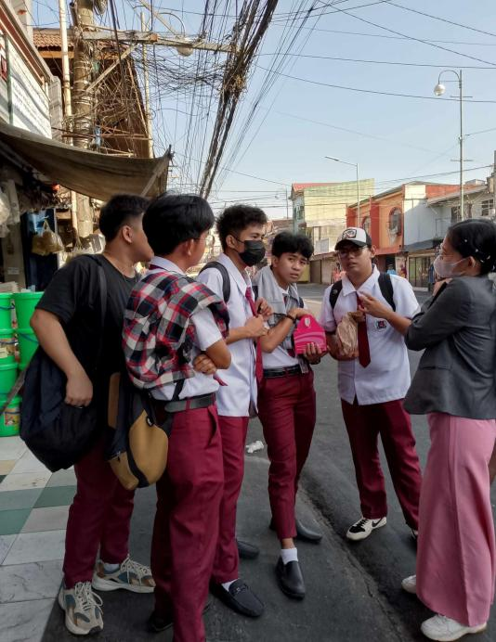

*Figure 5. Brainstorming Group meeting & Googlemeet on March. 2, 2024*

In this figure, after acquiring a client, the researchers are strategizing the system's future plans for the client.

## Adviser

Mr. Jaypee Abando, who helps the proponents guide the thesis project in a proper and easy way, He is usually the adviser for the thesis project and the revision of the thesis project. He formulates the steps or guides our thesis project to gain more ideas and improve our thesis project. Also, our IT Head, Mr. Michael Forbile, helps us make our thesis project more elaborate to make our project better.

## Sample Thesis

*Figure 6. Sample Thesis from Datamex College of Saint Adeline Inc.*

One issue that Top Glass Aluminum Center is dealing with is its subpar inventory, which can be filled out manually on paper or by typing it into Microsoft Excel, which can take hours to finish. Therefore, recording inventory faster is insufficient to maintain a six-month inventory. The purpose of this research is to improve the inventory system for Top Glass Aluminum Center.

The study starts with data analysis, which includes the current system and will be modified to construct an updated inventory system to meet user requirements. It will shorten the time needed to inventory the goods, cut down on repetitive inventory items, and improve business operations efficiency. All these technologies, though, are employed in the real world of business to keep up with suddenly change.

## Relevance of Sample Thesis

The Sample thesis entitled Analysis and evaluation case of:

"Computerized POS System for Shawarma Shack in COA Outlet."

Provide a solution on the problem of having a poor inventory system for Top Glass Aluminum it does record data on a using Microsoft Excel they input manually. Their study and problems encountered have been like the research that we conduct.

## Sample Report

*Figure 7. Sample Report/ Sample of transaction receipt of Top Glass Aluminum*

*Figure 8. Sample Report, Sample Receipt from the supplier of Top Glass Aluminum*

# CHAPTER 4 DOCUMENTATION OF THE CURRENT SYSTEM

## Definition

Giving a review summary of the client`s present system and presentations of the Inventory Management System by the owner and developed by the researchers.

## DESCRIPTION OF THE CURRENT SEMI-MANUAL SYSTEM

* + 1. **Inventory Records**

These are written or printed lists that include the unit price, location, and other pertinent information along with the items and quantities that are currently in stock.

* + 1. **Inventory Tracking**

Inventory tracking is usually performed using simple spreadsheet software. Every time there are changes in inventory such as receiving, transferring, or selling items, the details are manually recorded in a ledger or inventory log. This includes item description, quantities, dates, and unit costs.

* + 1. **Manual Reporting**

Inventory reports are created by gathering data from the inventory records. They contain details on current inventory levels, stock turnover rates, and inventory valuation.

**4.2.4 Stock Taking**

Regular inventory checks are done by hand to verify the accuracy of stock records. This involves physically counting the items in storage and comparing them with the documented amounts in the inventory.

* + 1. **Storage Warehouse**

Used to store or to stock inventory items that can be labeled for easy identification of stocks.

## HARDWARE & EQUIPMENT SET-UP

**4.3.1 Filing cabinet**

It is used to hold important data files to store inventory sheets, document logbooks, history documents and other important files that are included in business.

* + 1. **Inventory Sheet**

The inventory sheet checks what you have available in your items. It also includes what are the missing items in business.

* + 1. **Calculator**

Calculators are used to manage inventory levels, compute totals, and add up quantities. It contributes to accurate stock tracking, particularly in situations involving big volumes or intricate computations.

* + 1. **Logbook**

To record the inventory management, it includes the tracking of the items such as item codes, name of the item, quantity, also the remaining balance of the items.

* + 1. **Ball Pen**

It is used to write logbooks, records and for receipts.

* + 1. **Receipt**

It used to be that when the customer purchased a specific item and left a receipt, the receipt contained information about what the specific item was, the date, price, and proof of transaction to the specific store where the item was bought.

## SOFTWARE BEING USE

* + 1. **Windows 10 OS**

The OS what the client used to manage the inventory.

* + 1. **Microsoft Excel**

It is used to sort out the stocks of the item and also to list the record of the past and coming transactions.

## PERSONELS (5)

**4.5.1 Owner (Mr. Jayvee Mendoza)**

Currently the owner of Top Glass Aluminum Center has the capability to access the system, release items, and add new items. He is the only one to access the functions of the system.

.

* + 1. **Founder (Mr. Carlos Mendoza Jr.)**

He is the founder of Top Glass Aluminum Center.

* + 1. **Admin**

Top Glass Aluminum Center Branch managers are managing the Inventory system and 3 Branches located in Pampanga, Makati, and Taguig. Mr. Jayvee Mendoza manages the Taguig branch, while the other two branches have their respective admins. The admins can access the system but with limitations or restrictions, while some functions may not be available to them. However, Mr. Jayvee Mendoza doesn`t have any restrictions.

## CONTEXT DIAGRAM OF THE CURRENT SYSTEM

## Inventory Cycle

# CHAPTER 5 SYSTEM DESIGN AND SPECIFICATION

## System Design

## For coding software, the proponents using a Visual Studio Code for developing System Inventory Web development

## To encode the items or list items act for data store will be using a MyPhp Admin database.

* For the bridge for accessing database base will be **Xampp Control Panel** will be bridge to the Visual Studio Code.

## System Function

The proponents are developing a system that includes a distinct set of commands with the capability to execute various functions of a system inventory.

## Website UI

* + 1. **Login Section**

To access this part of the Log in page, you must first log in to the proponent`s account that has been provided. Every time the user logs in has constraints, except for the business owner. This was created for the establishment`s owner`s security and safety.

*Figure 9 Login UI*

s

1. **Landing Page Section**
2. *A screenshot of a phone

   Description automatically generated*The landing page`s purpose is to display inventory analytics. Owner can select a particular window from the menu on the left navigation bar, having their access of any branches and can see what the history of every branch is.

*Figure 10.. Landing Page*

1. **Product table Section**

This Product table section shows that every product is unique product types such as glass, aluminum, steel, hand tools etc.

*Figure 11. Product table section*

1. **Product Records**

This function is used to view records of products history.

*Figure 12. Viewing all Product Records*

1. **Category records**

This function is to records of the item categories.

*Figure 13.. Categories section*

1. **Add category details**

This is a designed to adding a another new another category for the inventory.

*Figure 14. Categories details*

1. **Release products section**

This is a designed to release a product to the customer.

*Figure 15. Releasing product details*

1. **Add Product**

This is a designed to adding a product when having adding a stocks.

*Figure 16. Add product section*

1. **Users**

This is designed to see who’s the authorized user for the Top Glass Aluminum center.

*Figure 17. User details*

# CHAPTER 6 SYSTEM IMPLEMENTATION

## Definition

In this chapter the proponents will determine the system specification requirements to run the program properly, the system requirements must meet otherwise the program will not function properly.

The proponents consider the usage of the system. They must make sure that the user can easily adapt and understand the basic function and use of the system. The IDE (Integrated Development Environment) of the said system is implemented for the user to utilize the system very well, which is why we use the Microsoft Visual Studio 2013, because of its user-friendly interface and environment unlike its predecessor programs, furthermore, we consider the database that’s why we use the Microsoft Access as the storage of data or the database for the information and data of the system.

## Hardware and Software Installation

* 1. **Hardware**
     + **Personal Computers**

This is not that portable, but it can also help to view the inventory system in each branch of business.

* + - **Receipt Printer**

Are required in every establishment, providing customers with proof of purchase. Some factors to consider when purchasing a receipt printer are the print method, print speed, and any features, such as Bluetooth or Wi-Fi, that best suit your needs.

* + - **RJ45 Lan Cable**

A type of connector commonly used for internet cables to connect computers. It is the standard connector for networking cables used in most wired internet connections.

* + - **Hub**

A hub is used to connect various devices such as phone, tablets, laptop/desktop computers etc.

* + - **UPS - Uninterruptible Power Supply**

An uninterruptible power supply or uninterruptible power source (UPS) is an electrical apparatus that provides emergency power to a load when the input power source or mains power fails.

* + - **Hard Disk for Data Backup**

Hard disk backup is a process to create a complete copy of everything in a hard drive to another HDD/SSD or an external hard drive. With a hard disk backup, you can fully protect your computer data from the following disasters Virus attack, Accidental deletion, Careless formatting, Hard drive corrupted, OS crash or boot issue.

1. **Minimum Specification**

|  |  |
| --- | --- |
| **Devices / Hardware** | **Devices/ Hardware Specs** |
| **CPU OR PROCESSOR** | At least (Intel® i3 4th Gen processor or higher processor/generation. |
| **SSD** | At least 250 gigabyte capacity of the hard disk or SSD |
| **MEMORY (RAM)** | At least a minimum of 4x2= 8 gigabytes of physical ram for fast performance (random access memory) |
| **MONITOR** | At leastStandard Wide type of monitor capable of wide displaying and a minimum of 1024 X 768 Aspect ratio at a refresh rate of 60 hertz. |
| **KEYBOARD** | Any keyboard type for everyday use. |
| **MOUSE** | We recommend Standard **Laser Mouse** for accuracy. |
| **FLASH DRIVE** | A Standard **2.0 or 3.0 USB** pen drive of 8GB capacity for portable backup |
| **UPS** | * Model: APC BVX1200LI-MS * Wattage: 650W/1.2kVA * Number of outlets: 4 outlets * Frequency: 60Hz * Recharging Time: 8hrs * Size:   Max Height: 190MM, 19.0CM  Max Width: 140MM, 14.0CM  Max Depth: 390MM, 39.0CM |
| **ACTIVE HUB** | * Communication Mode: Full-Duplex & Half-Duplex * Ports: 6 Switch Capacity:1G * Transmission Rate:10/100Mbps |

**6.2.1.2 Maximum Specification**

|  |  |
| --- | --- |
| **Devices / Hardware** | **Devices/ Hardware Specs** |
| **CPU OR PROCESSOR** | At least (Intel® i5 8th Gen processor or higher processor/generation. |
| **SSD** | 500 gigabytes capacity of SSD for big loads of files. |
| **MEMORY (RAM)** | Recommended of 8x2= 16 gigabytes of physical ram for fast performance (random access memory) |
| **MONITOR** | Standard Wide type of 27-inch monitor capable of displaying a wide space of work display. Recommended 1920 X 1080 Aspect ratio at a refresh rate of 60 hertz. |
| **KEYBOARD** | Any keyboard type for everyday use. |
| **MOUSE** | We recommend Standard **Laser Mouse** for accuracy. |
| **FLASH DRIVE** | A Standard **2.0 or 3.0 USB** pen drive of 8GB capacity for portable backup |
| **UPS** | * Model: APC BVX1200LI-MS * Wattage: 650W/1.2kVA * Number of outlets: 4 outlets * Frequency: 60Hz * Recharging Time: 8hrs * Size:   Max Height: 190MM, 19.0CM  Max Width: 140MM, 14.0CM  Max Depth: 390MM, 39.0CM |
| **ACTIVE HUB** | * Communication Mode: Full-Duplex & Half-Duplex * Ports: 6 Switch Capacity:1G * Transmission Rate:10/100Mbps |

* 1. **Software**
     + Windows 10 x86 or x64 or later (32bit and 64-bit).
     + Xampp Control Panel
     + Google chrome for accessing database (PHP)
     + Microsoft Visual Studio Code (2024)
  2. **Personnel**
     1. **Owner (Super Admin)** 
        + Security of the system
        + System Account
        + Add a user Account.
        + Edit user Account.
        + Login Module
        + Inventory
        + Add Function
        + Edit Function
        + Delete Function
     2. **Employee (Admin)**
        + Login Module
        + Inventory Module
        + Add Function
        + Edit function
        + Delete Function

## Configuration and customization

The Web-based Inventory needs to be precise about the number of products that can be entered and exited, as well as the item codes and prices. In the unlikely event that an inventory system malfunctions, support for resolving issues and continuous operation is offered.

For Inventory system to function properly, it must have a computer and having steady power to operate the system. A computer is a component of Inventory system, without computer the Inventory system would not work. A computer has a supply of power because of the unexpected power interruptions causing damage of computer, but also the Inventory system software itself. To complete an Inventory system, it needs an additional peripheral to type for Inventory of items.

The peripherals include in Inventory system where the Inventory system works on, checking the items which can read on the items codes that`s bring up the quantity, price of the specific item and name of the item.

## Data Migration

The proponents are required to ensure that the system's hardware and software are safe and up to date. after the proponents have verified all the hardware and system prerequisites. Either cloud storage or email must be used as a system backup.

## Backup & Data Recovery

Back-up and Data Recovery can be secured the loss data of inventory system can be avoid loss tracking or securing inventory management. Backup procedures is to reduce the system failures, data breaches, or natural disasters, backup methods include replication of inventory records and transactional data. In both practical applications, data recovery effectively recovers and restore the backed-up data precise stock tracking, and regulatory compliance.

1. **Backup and Recovery procedure**

The following process will detail how the proponents carry out backup and data recovery, as well as how users handle this kind of process:

Data backups will be performed every month (Monthly).

* Backups performed every 2 weeks on Saturday after working hours will be kept for a month before recycling.
* Backup files will be sent to the developers via email or google drive link.
* The backup file is stored in a hard disk or flash drive by the developers when they receive the file from the admin.
* The Hard disk or Flash Drive must be stored off-safe in a safe place.
* The backup function will cover all the functionable access on the website.
* Once the data is lost IT staff or the developer will proceed to restoration of data from backup media.

## Testing (Testing the system on the client part)

Before deploying, the proponents will thoroughly check the system and the browser twice. ensuring that there are no problems in the system prior to the preceding system unit check. Proponents will also examine the computer's performance and the system unit's characteristics. They can use the system once all prerequisites have been satisfied.

## Training and Implementation used.

To use the inventory system, the client and the staff shall learn how to use the Inventory system in browser that the proponents propose. The proponents know all the analysis of the system and implementing the system in the actual process. We came up the idea to run the system at multiple pc at the same time.

The Parallel and the Pilot Implementation. In parallel implementation involves running both systems concurrently until the users are ready to make the switch from old inventory system to new inventory system, and the pilot is a small-scale implementation of the project, with a limited group of users. By using those implementations, the users haven’t had the hard time studying and adopting the new system.

# CHAPTER 7 JUSTIFICATION AND CONCLUSION

## Justification

* The system will provide a new method of listing product details that will benefit to the business.
* The system will provide fast stock or product monitoring.
* The system will reduce errors and produce more accurate results for the product listing and customer details.

## Conclusion

* That the clients shall experience a convenient way of recording multiple items.
* It helps the client to input the product description.
* The client can easily monitor the product records.

# CHAPTER 8 RECOMMENDATION

## Recommendations:

## Enhance Security Features:

**Role based Access Control (RBAC)** **–** Putting in place a mechanism that restricts system website modification to authorized personnel only. This will involve assigning management and staff members to certain roles or access levels.

**History trails –** A history trail to log all the activities of any branch managers in all branches. It really helps to track unexpected changes of inventory.

**Adapting in Mobile Device:**

**Crossover Platform (Mobile Device) –** A mobile website version of the inventory system will allow to manage the inventory without opening a computer. It will be updated the inventory system in a mobile phone in real-time updates without visiting the other branches.

**User Training Support:**

**Training programs –** Providing training programs of all employees of the Top Glass Aluminum Center. This will help that all the staff/employees are proficient in using system inventory.

**Bugs encountering & Feedback –** Establishing what are the bugs that countering of the employees to suggest improvements of the system.

**Securing the System:**

**Cloud System back-up –** Integrating a cloud storage for data back up to recover all the data files and the data security across all branches.

**Regular System Updates:**

**Software Updates –** Keeping the software are up to date with latest features and security updates to avoid the vulnerabilities of system and improving the functionality of website.

**Security Updates –** Keeping the security are updated to avoid the DDoS attacking of the system.

**CHAPTER 9: IPO (??)**

**CHAPTER 10: VTOC (??)**

**CHAPTER 11: (FLOWCHART)**

**CHAPTER 12: CBA (Cost Benefit Analysis)**

**Curriculum Vitae:**



